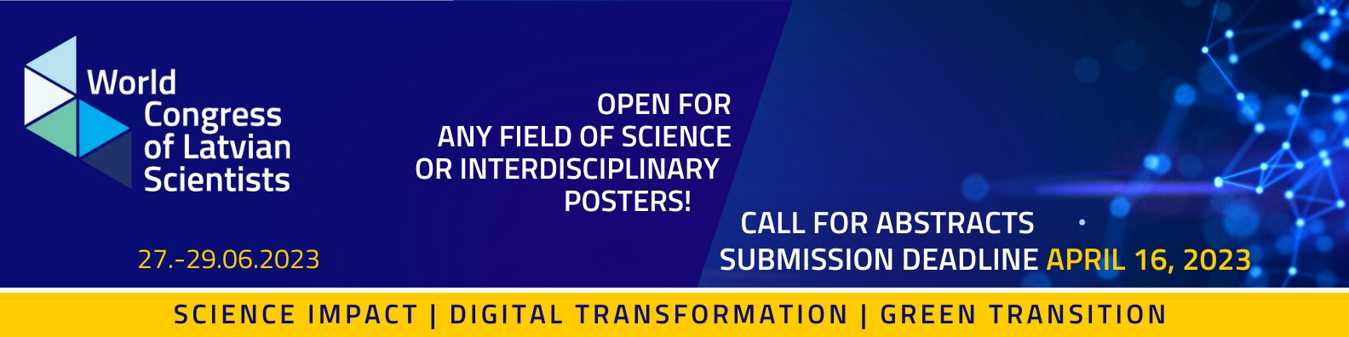

Abstract Submission
The Scientific Committee of the Congress has developed a two-day programme that includes thematic discussions, speeches, seminars, demonstrations and other activities of different formats. In addition, scientists, doctoral candidates and students from Latvia and of and Latvian origin all over the world are invited to submit abstracts in an open call for poster presentations.
Applications shall be submitted in Latvian and English or only in English by 16 April 2023 via the Congress website www.sciencecongress.lv.
Abstracts for posters
The Scientific Committee of the Congress is pleased to invite submissions of abstracts for poster presentations. In order to submit a poster to be exhibited at the Congress, an abstract (max. 200 words long) is to be submitted. In the abstract in between other crucial information, authors are encouraged to specify the potential of the research results to boost Latvia’s growth, e.g. technological development, improvement of people's wellbeing (physical and mental well-being), health, economy, and environment. Challenges and solutions to overcome them can be most successfully identified through interdisciplinary cooperation in research, as well as by cooperating with the industry and society (participatory research), therefore poster presentations under any field of science or interdisciplinary posters are welcomed. The Scientific Committee of the Congress invites authors to present their posters to also spark an interest in scientists from other fields.
Useful information
A cross-disciplinary international scientific jury panel will carry out a blind peer review of the poster applications in line with the objectives and topics of Congress. After the review and the initial selection process, applicants will be invited to prepare posters for presentation in digital format to be presented in the congress.
If the subject of the selected poster abstract corresponds to one of the three main topics of the congress – Green Transformation, Digital Transformation, Science Impact – the Scientific Committee of the Congress may invite these applicants to take part in the congress as a speaker (on the subject of the poster) in one of the parallel sessions, by presenting the matters of the study of the submitted poster abstract. In such cases, communication will be conducted separately after the initial selection.
Good luck! We are looking forward to meeting you at the 5th World Congress of Latvian Scientists “Research Latvia”!

